ENGLISH LANGUAGE PAST QUESTIONS AND ANSWERS

This past questions is compiled by ghstudents.com and it’s to serve as a study guide for candidates participating in the West African Examination Council (WAEC) examination. This past question is **NOT FOR SALE**.

**English Language Past Questions (OBJECTIVE) 2020**

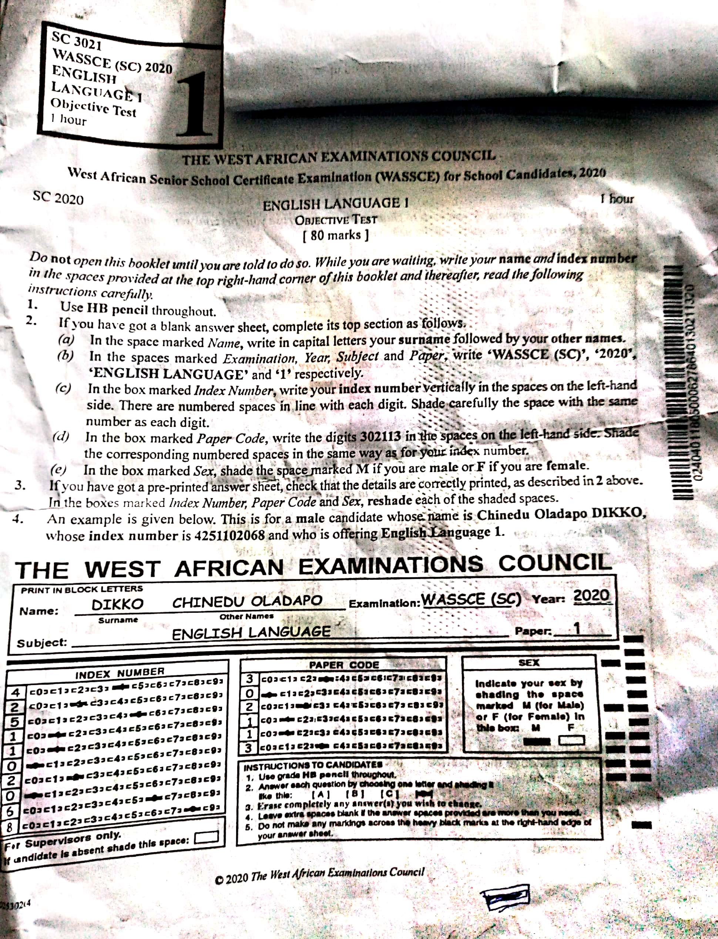

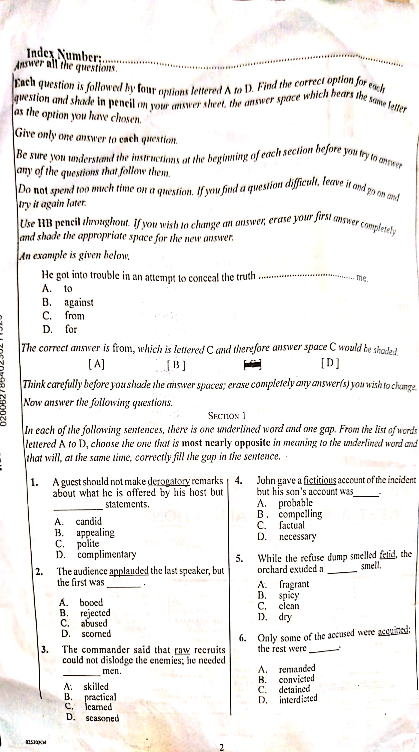

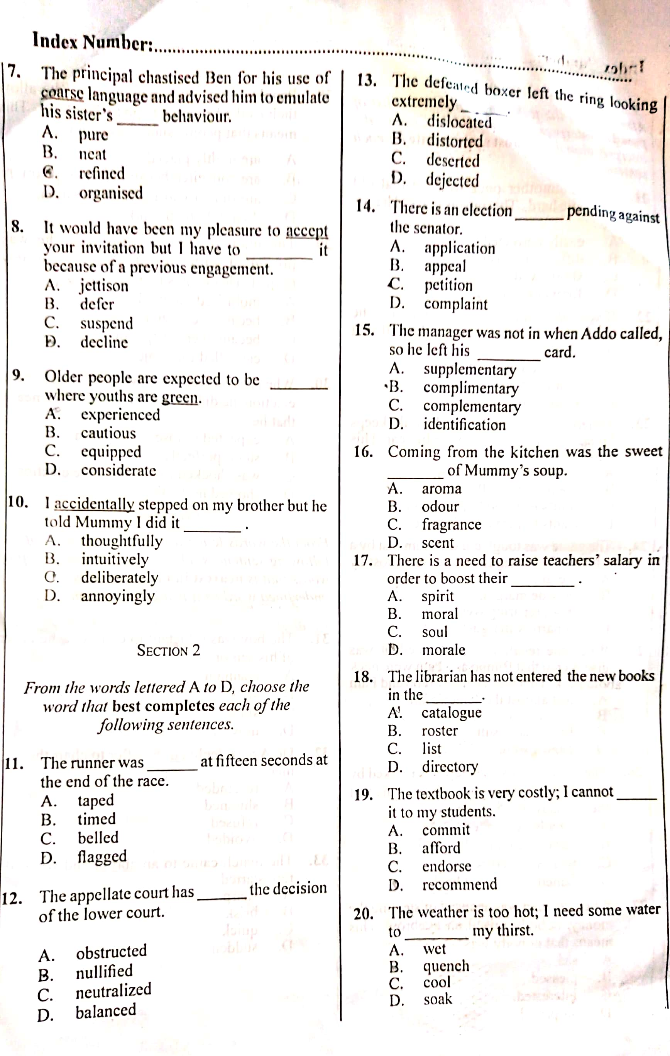 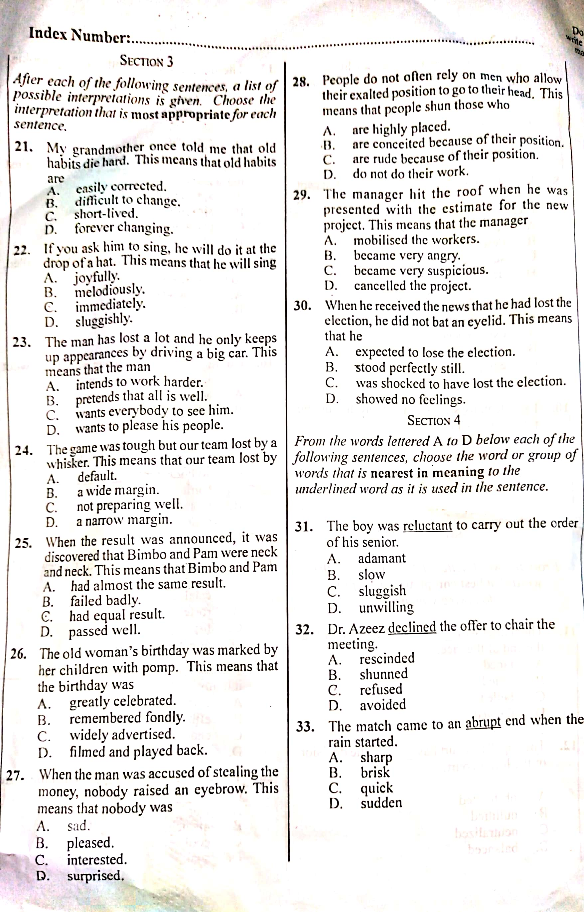

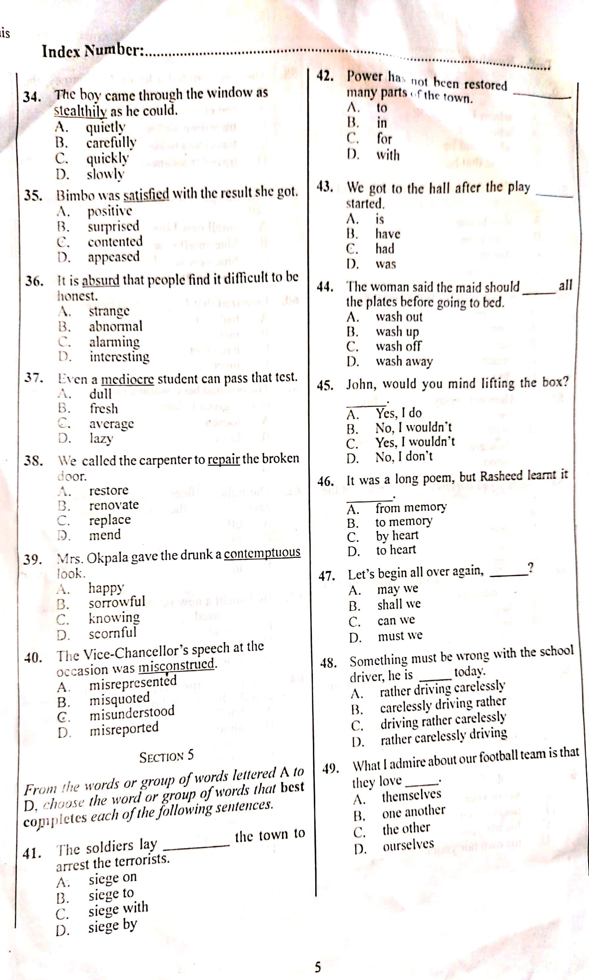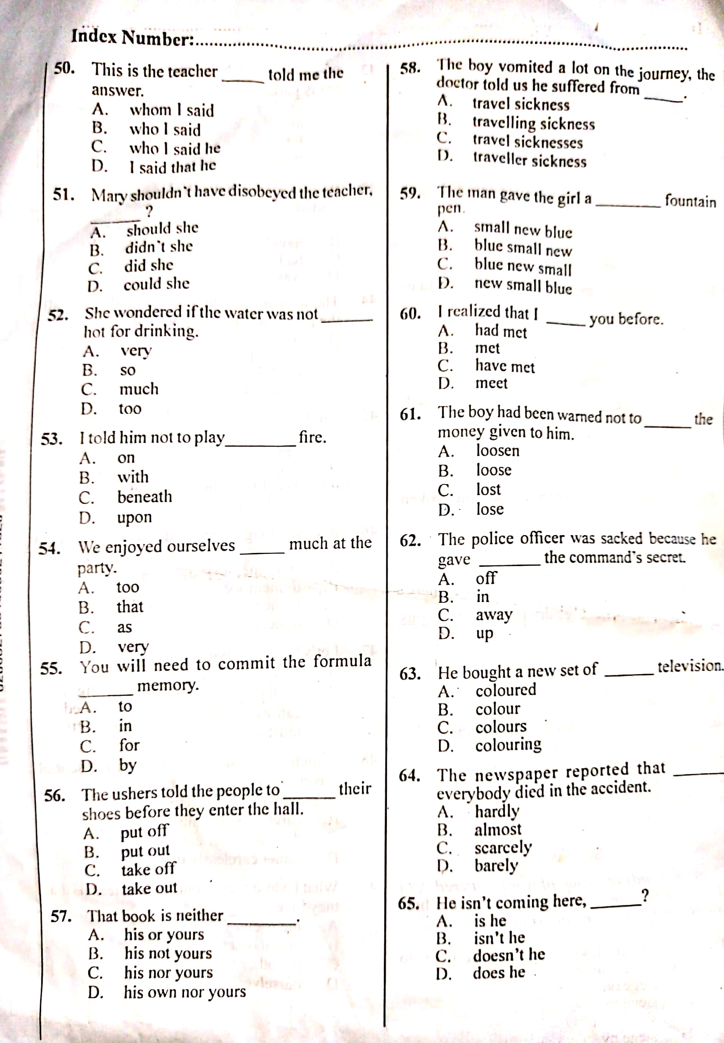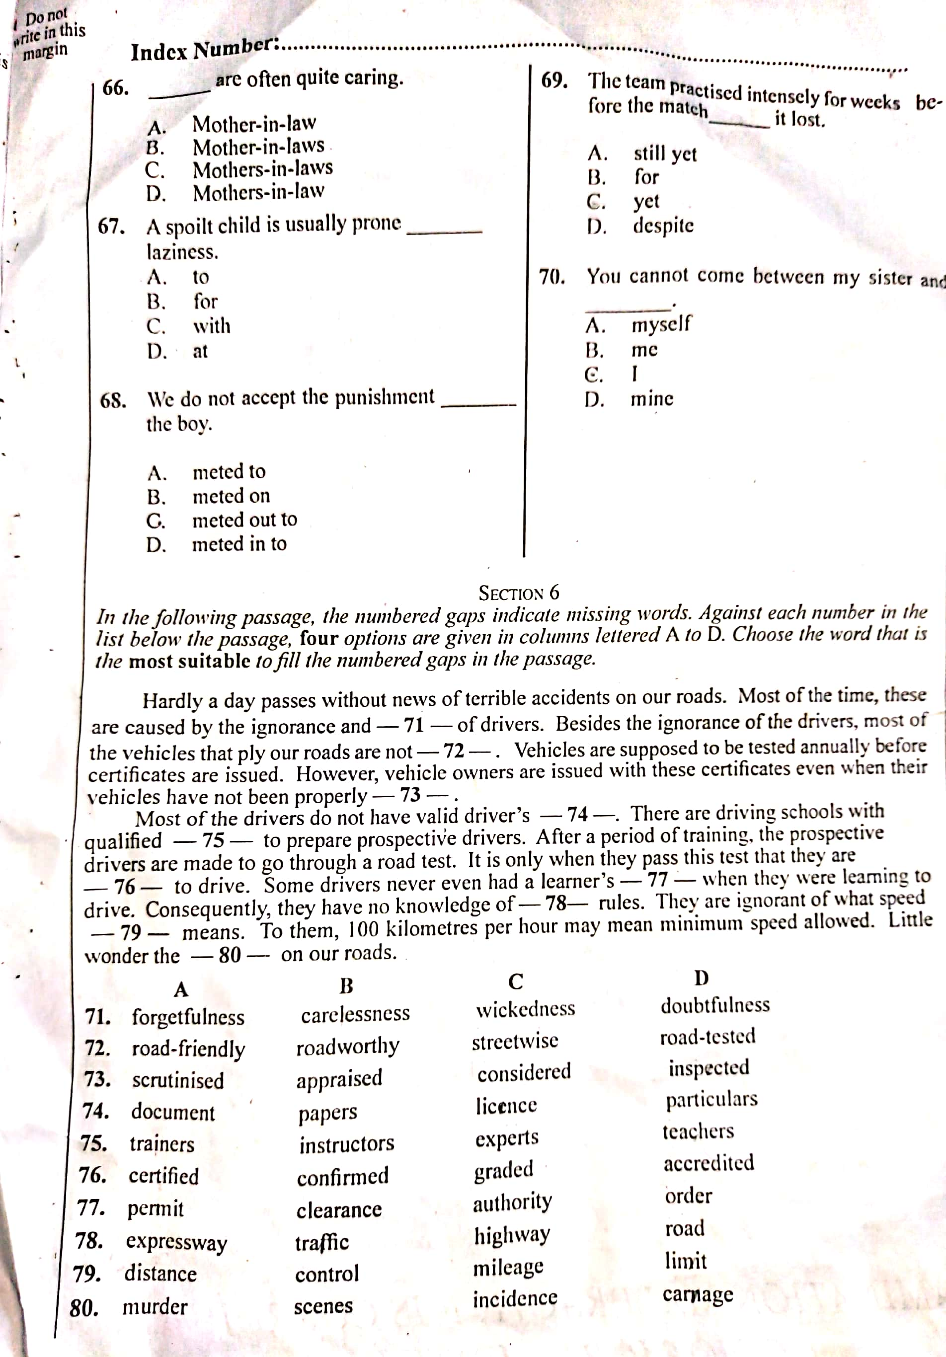

**English Past Questions and Answers (Objective) 2020**

**1 – 10: DAACABCDAC**

**11-20: DBDCBADADB**

**21-30: BCBDCADBBD**

**31-40: AACBBCBCBB**

**41-50: AACBBCBCBB**

**51-60: ADBDACCADA**

**61-70: DDABADACCC**

**71-80: BBDCDAABDD**

**English Language Past Questions (ORAL) 2020**

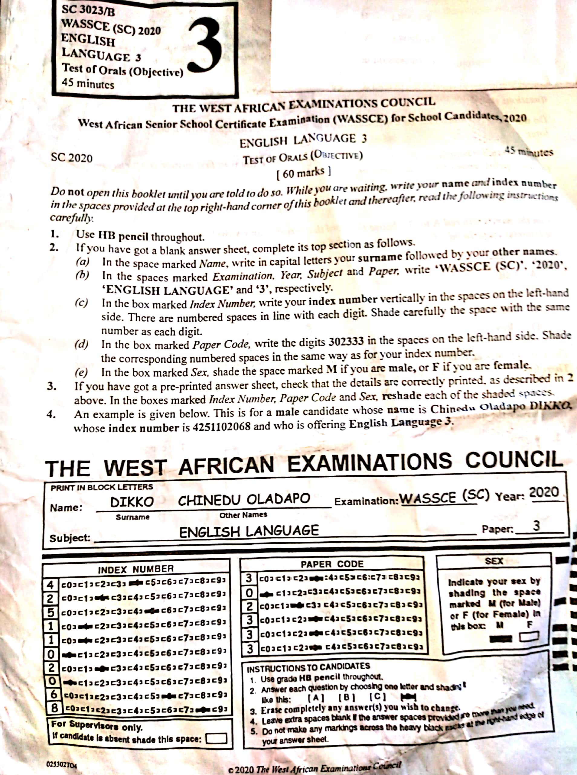

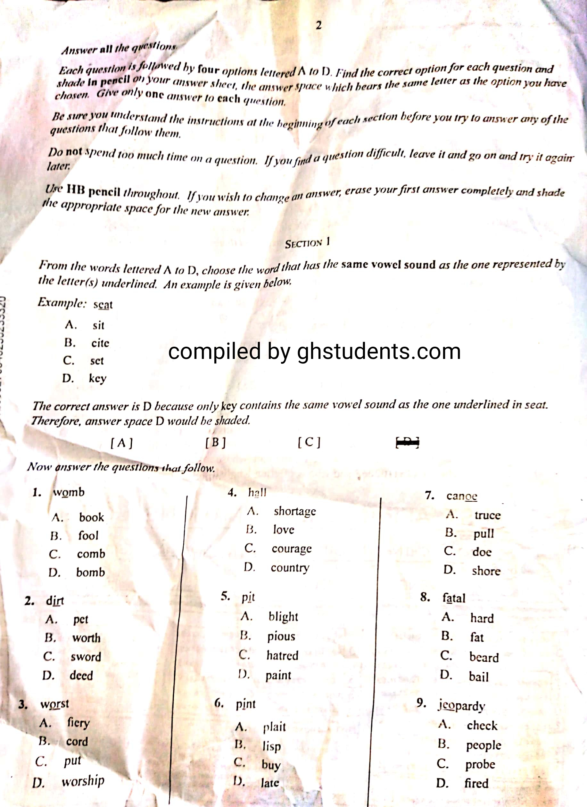

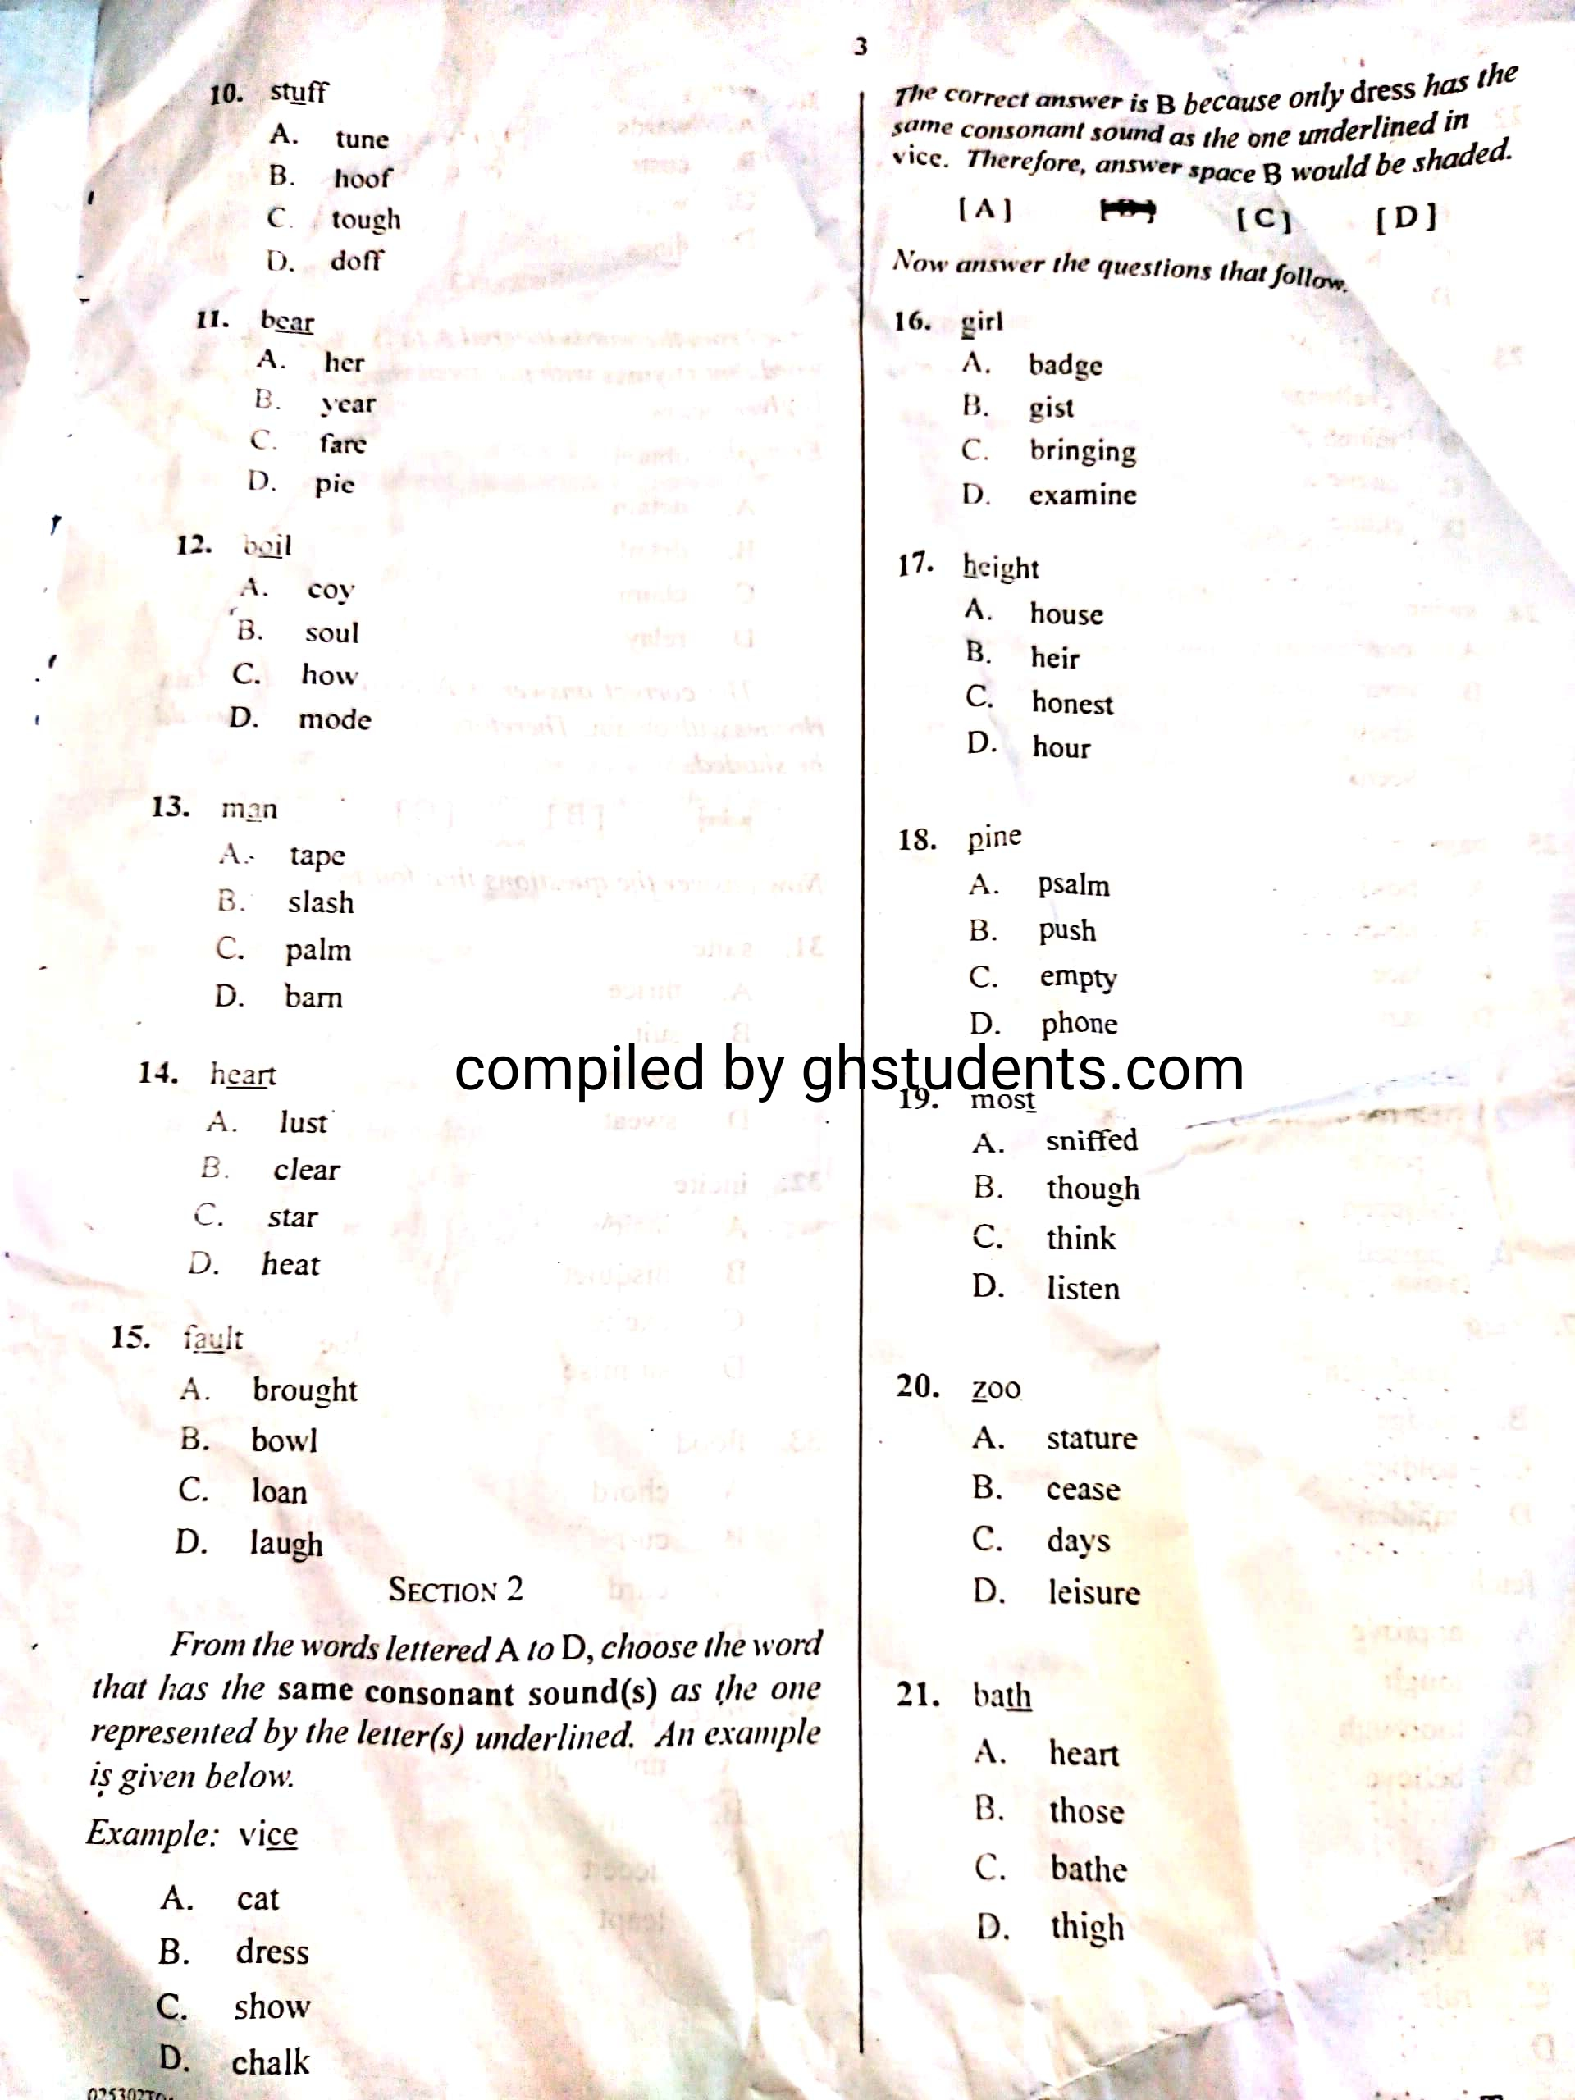

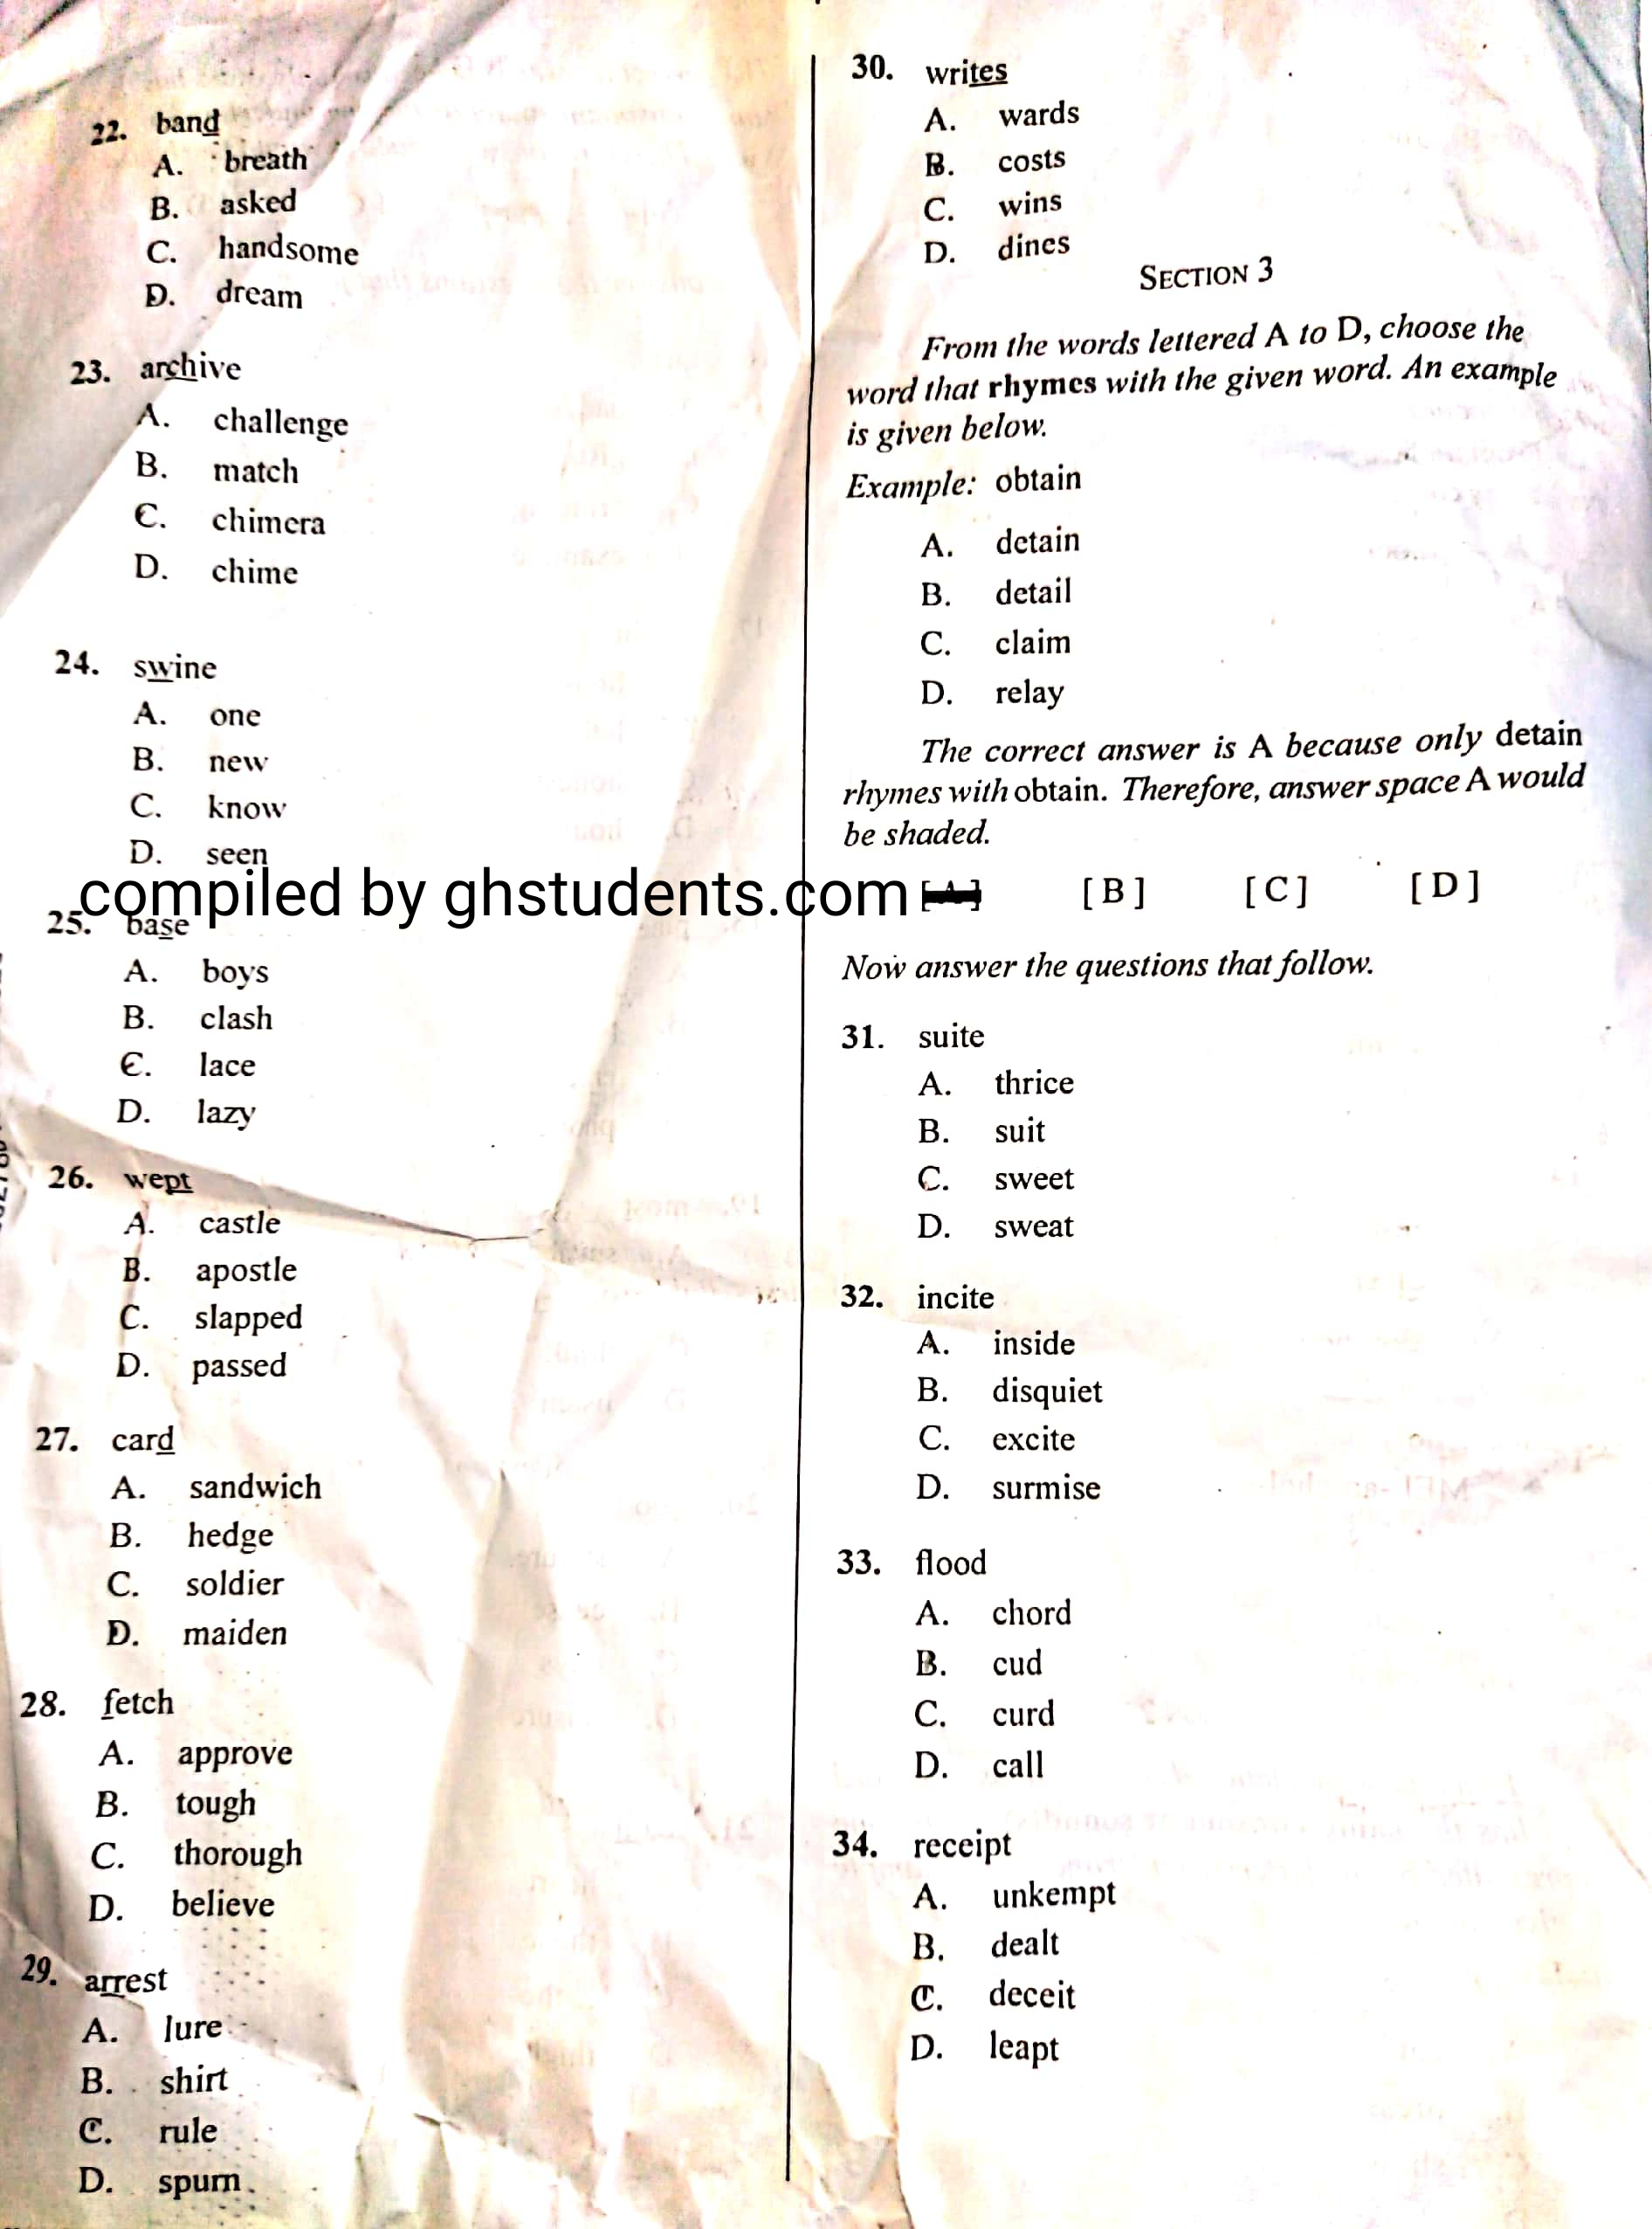

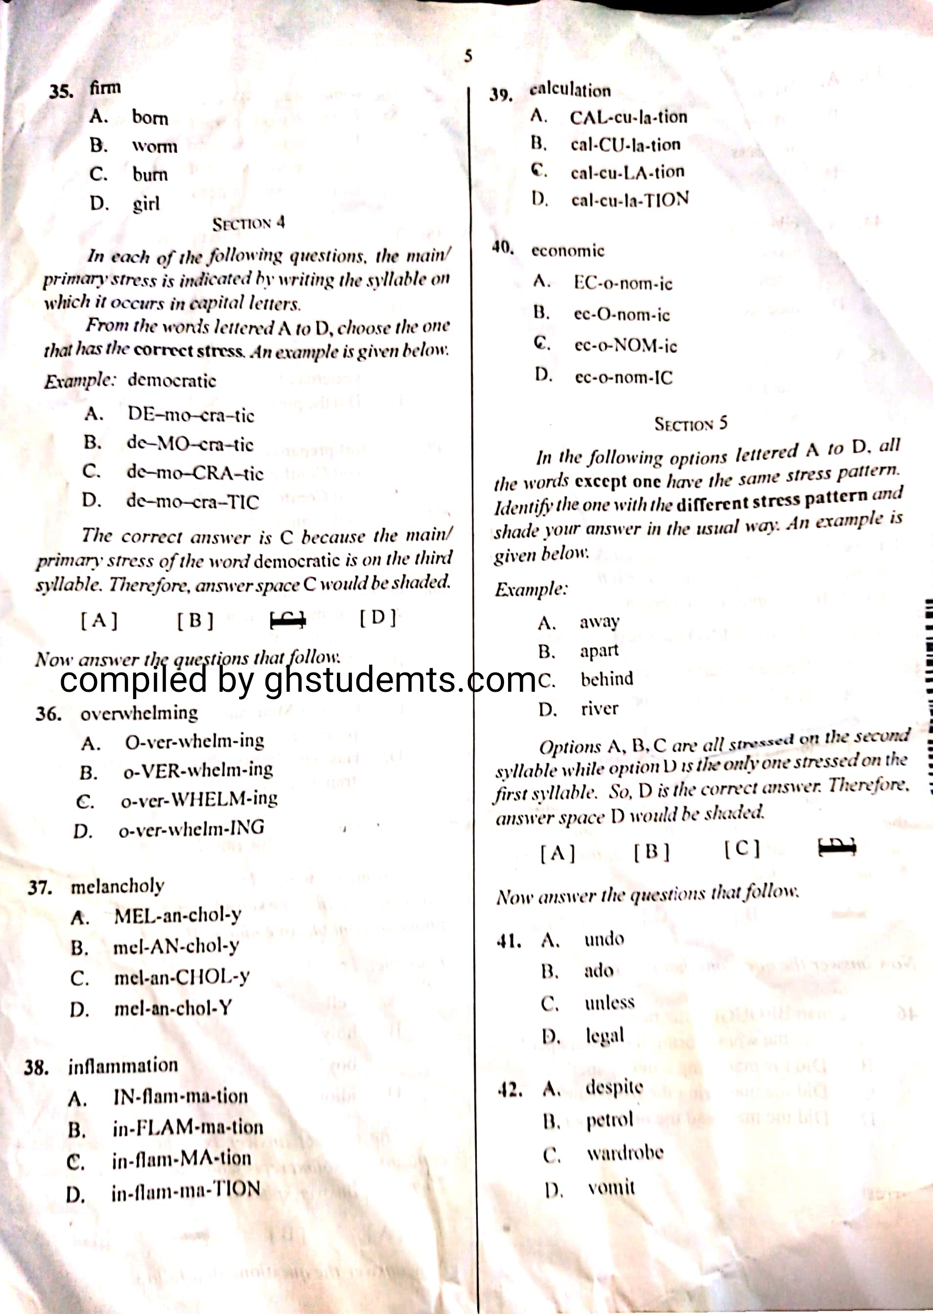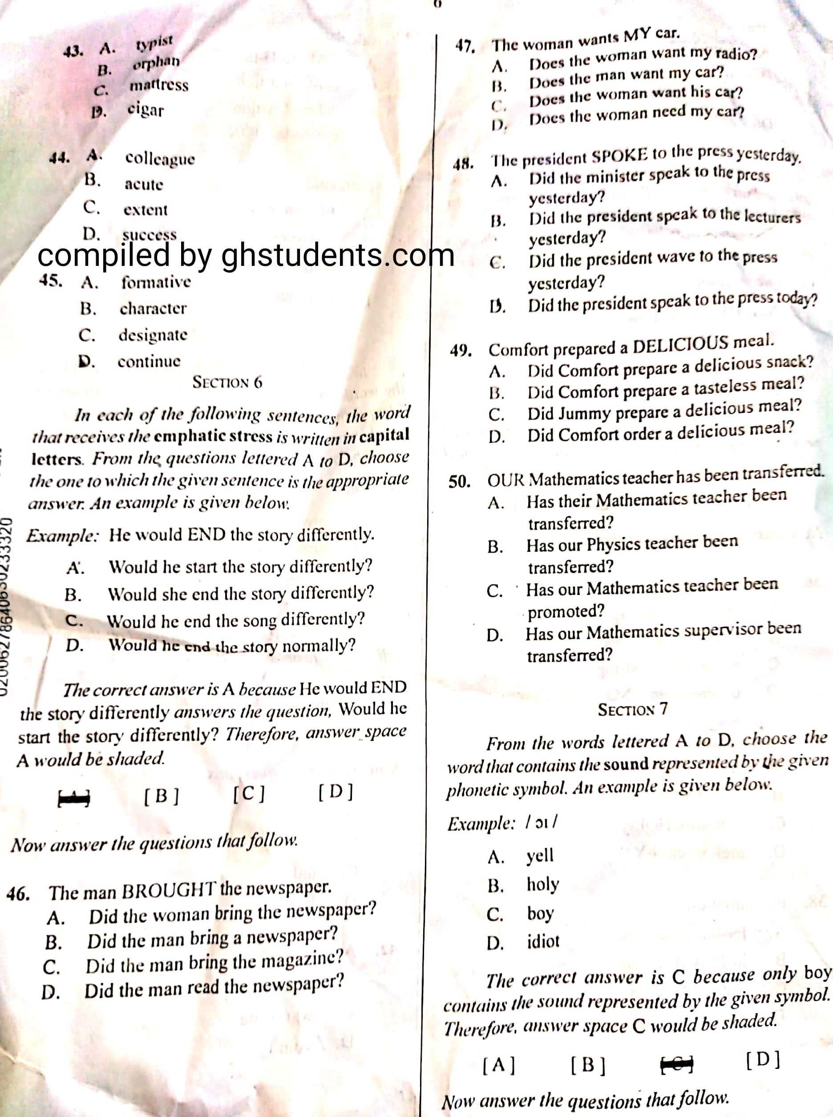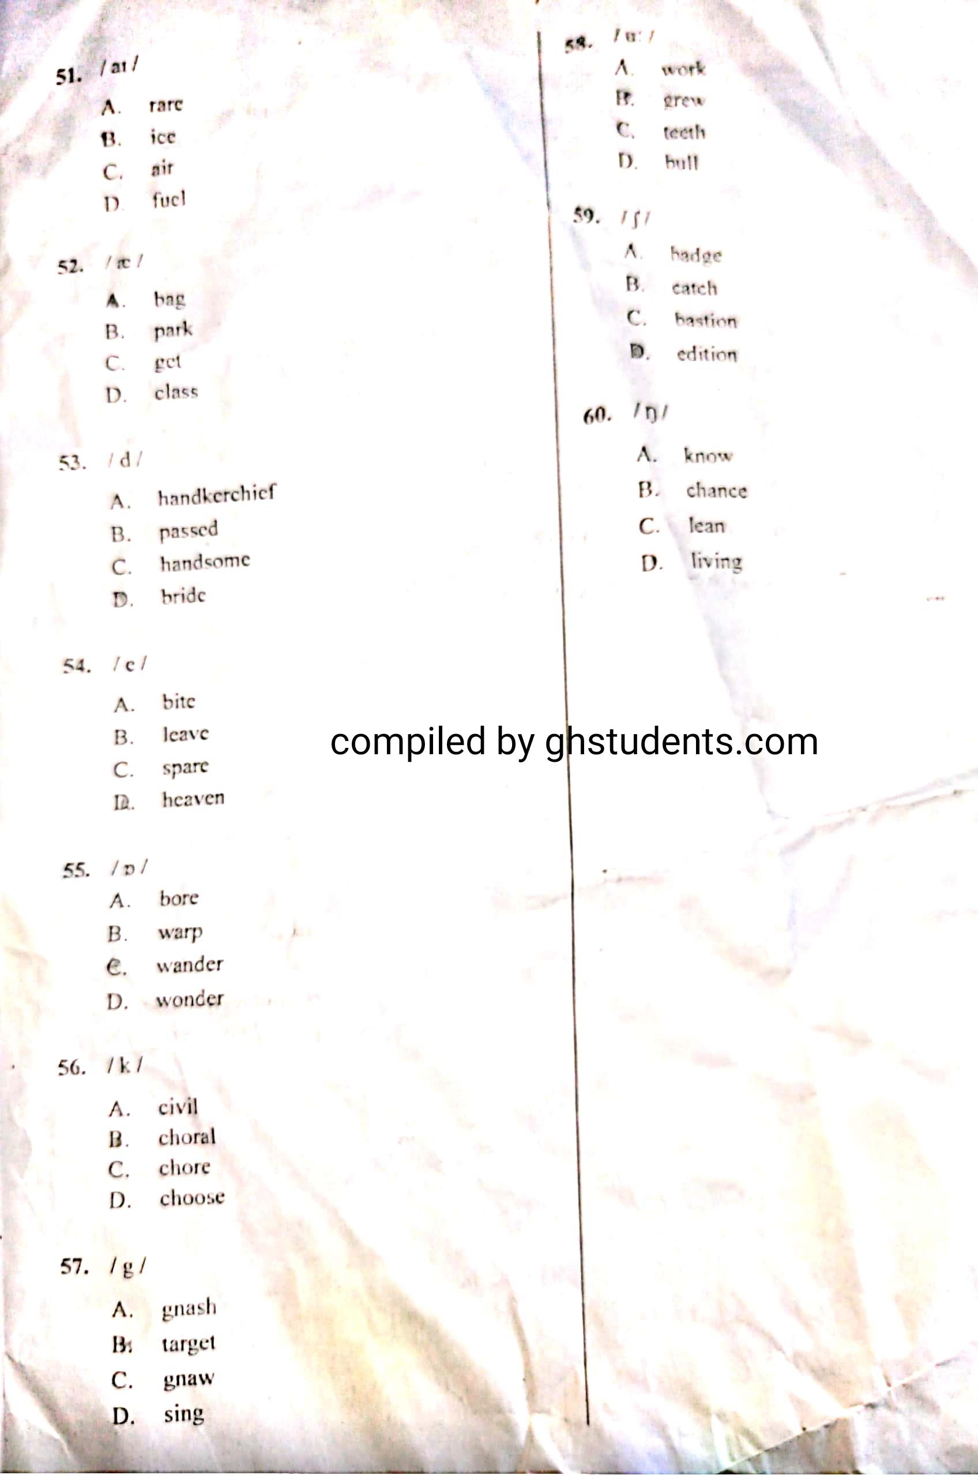

**English Past Questions and Answers (Oral) 2020**

**1 – 10: BBDACCADAC**

**11-20: CABCACABAC**

**21-30: DDCACDDBCB**

**31-40: CABCBCACCC**

**41-50: DADADDCCBA**

**51-60: BADDCBBBDD**

**English Language Past Questions (ESSAY) 2020**

